Name:
Class:
Element Social Media Project
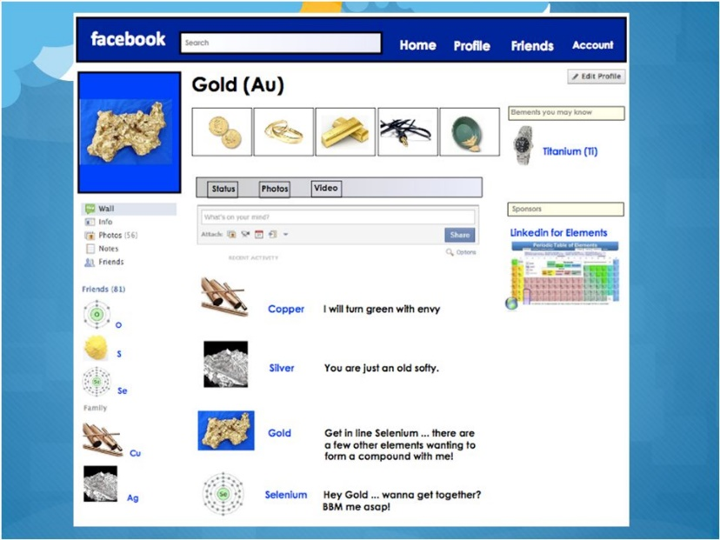
My element:
___________________________________
You will be doing research and making a fake social media profile for an element of your choice. You can model it off Instagram, Snapchat, Facebook, etc. This project is due on Friday at the beginning of class. You will be presenting your project to the class, please practice your presentation at home!

For full credit, you must find a way to show all the following: Point value
- Name and symbol of element 2 1 0
- Is this element usually found as a solid, liquid, or gas? 2 1 0
- Number of protons, neutrons, and electrons in an atom of your element 3 2 1 0
- 2 or more pictures of your element (include 1 picture of an atom of your element) 2 1 0
- Where the element lives/who is its family (on the periodic table) 2 1 0
- About your element (three physical or chemical properties) 3 2 1 0
- Where the element likes to hang out (where it is found in nature) 2 1 0
- Who it follows (other elements it hangs around with/forms compounds with) 2 1 0
- What the element does in its free time (what are some practical uses of this element?)2 1 0
In addition, points will be awarded for:
- Neatness and creativity of project 5 4 3 2 1 0
- Presentation-quality and clarity 5 4 3 2 1 0
Total Score _________ /30
Comments:

Name:
Element:

- Name and symbol of element 2 1 0
- Is this element usually found as a solid, liquid, or gas? 2 1 0
- Number of protons, neutrons, and electrons in an atom of your element 3 2 1 0
- 2 or more pictures of your element (include 1 picture of an atom of your element) 2 1 0
- Where the element lives/who is its family (on the periodic table) 2 1 0
- About your element (three physical or chemical properties) 3 2 1 0
- Where the element likes to hang out (where it is found in nature) 2 1 0
- Who it follows (other elements it hangs around with/forms compounds with) 2 1 0
- What the element does in its free time (what are some practical uses of this element?) 2 1 0

- Neatness and creativity of project 5 4 3 2 1 0
- Presentation-quality and clarity 5 4 3 2 1 0
Total Score _________ /30
Comments:

Name:
Element:

- Name and symbol of element 2 1 0
- Is this element usually found as a solid, liquid, or gas? 2 1 0
- Number of protons, neutrons, and electrons in an atom of your element 3 2 1 0
- 2 or more pictures of your element (include 1 picture of an atom of your element) 2 1 0
- Where the element lives/who is its family (on the periodic table) 2 1 0
- About your element (three physical or chemical properties) 3 2 1 0
- Where the element likes to hang out (where it is found in nature) 2 1 0
- Who it follows (other elements it hangs around with/forms compounds with) 2 1 0
- What the element does in its free time (what are some practical uses of this element?) 2 1 0

- Neatness and creativity of project 5 4 3 2 1 0
- Presentation-quality and clarity 5 4 3 2 1 0
Total Score _________ /30
Comments:

