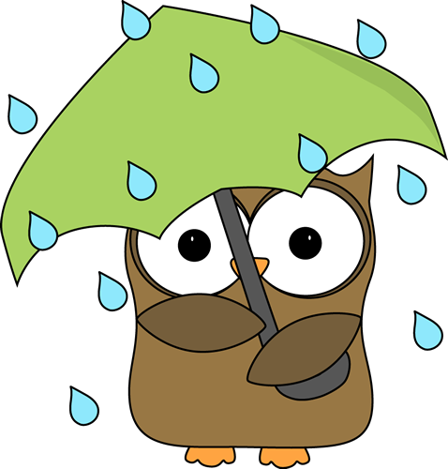

**Humanities:** As April begins, eighth-graders will get into their final class text for the year: Michael Pollan's *The Omnivore's Dilemma.*As we study this non-fiction text together, we'll try to decide whether the U.S. food chain is sustainable, using critical-thinking skills to analyze the cause-and-effect relationships Pollan presents in the his argument.

TPCS 8th Grade

Vol. 8 April 2018

**Tunbridge Public Charter Middle School**

It’s hard to believe that is April already and in just a couple of months we will be saying goodbye to this group of students. We have enjoyed our time with them, be it one or two years or more, and we know their legacy and impact on the building of this school has been huge over the past six 9 years.

All that said, in case you have not had an 8th grade student before or in case you were lucky enough to have one that avoided this, we also want to briefly talk about 8th grade spring. With high school placement letters in hand, the weather getting warmer, exciting activities planned, and the general exhaustion that comes at the end of any school year, 8th grade students can develop some new behavior and academic slips that were not present before. We hope that this group continues to take care of self and others to prevent this happening but know that we are going to maintain the expectations on our end until the end of the year. There will still be learning every day, there will still be homework, and there are still expectations and consequences that come with not meeting those expectations.

Kids earning more than 9 reflective lunches or 2 office referrals/suspensions are in danger of losing end of year activities. So, there’s that extra motivation as well!

Please continue to check in with them and us about their grades, their homework, and generally how things are going at school so we can have a fun, safe, and productive end to our year and their time at TPCS!

**Perfect Attendance in March**: Evelyn Blackman, Trevor Fortier, Amelia Henry, Taniya Hill, Jada Lewis, Tijah Mintz, Tenard Sheppard, and Grace Sutherland. **GREAT JOB TO YOU ALL!**

**Huge shout out to Jaden, Kenya, and AJ for representing 8th grade in the science fair. And especially TIJAH for winning it!**

Math – April will focus, again, on understanding and analyzing linear functions. This is the essential skill of 8th grade math so we are tackling it again and again and again until everyone gets it. Algebra students will begin reviewing/applying everything we’ve learned this year in preparation for PARCC.

Science: Our last months of science will focus on waves, light, sound, electricity, and magnetism.

**Dates to Note:**

* April 1st – 5th – Penny Wars
* April 3rd – Early release (11:30)
* April 5th – Coffee Klatch
* April 9th – Quarter 3 Ends
* April 12th – Q3 Awards List
* April 15th – 22nd – Spring Break
* April 23rd – School reopens
* April 25th – T-WAP meeting
* April 30th – PTO restaurant night at Chipotle