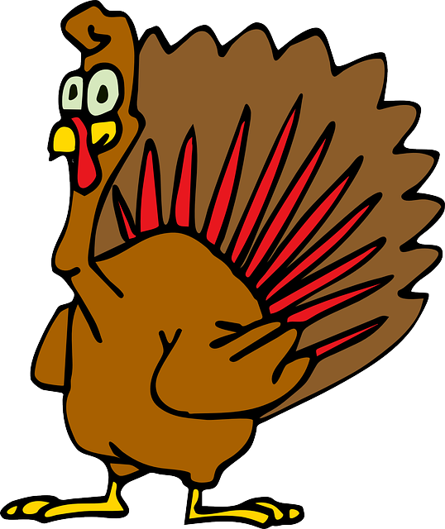

Math: This month students will wrap up our second unit, which will covered translations, reflections, rotations, congruence, and parallel lines cuts by a transversal. We’ll do a quick dive into the Pythagorean Theorem, and then move on to our next, fairly short, unit on similarity in figures using scale. Students in Algebra will be wrapping up our first unit and moving on to data analysis and statistics. Continue to access KhanAcademy for extra support with the material. ---Ms. Bovill & Mr. Arbuckle

Dates to Know:

* November 3rd – Afya Invitational 11am
* November 6th – NO SCHOOL (VOTE!)
* November 7th – **NYC deposit due;** Design School articulation; Quarter 1 ends
* November 8th – Dunbar articulation
* November 13th – City Preview Day
* November 14th – Cristo Rey articulation
* November 15th – STEM night/Spaghetti dinner 5:30-7pm
* November 21st - Bard articulation; early release
* November 22-23 – school closed
* November 28th – IND/Curley articulations
* December 1st – Pancake Breakfast

Vol. 3 November 2018

TPCS 8th Grade

Humanities: As the first quarter winds down, 8th graders will be wrapping up *Inside Out and Back Again* and starting to work on their final assessment for the unit -- a five-paragraph essay asking them to connect the novel's title to the universal refugee experience.

Once that essay is complete, we'll begin a short social-studies unit during which we'll explore the internment of Japanese Americans during World War II. All of our social-studies units this year will focus on some aspect of U.S history; I'm excited to get started.

Please continue to stay in touch with any questions or concerns.

---Mr. Ventre

Reminders:

Quarter 1 of 8th grade is still part of the composite score. Wrap up strong!

School starts at 7:55 and students are marked tardy at that time.

Uniform shoes and sweatshirts (solid school colors with a small logo) everyday!

**American Education Week (11/12-11/16):**

**11/12** – Attend morning meeting from 7:55-8:15

**11/15** – Drop in and attend a class with your child from 8am-2pm (schedule on back)

**11/16** – awards assembly at 1:30 in gym

Tunbridge Public Charter Middle School

**Science:** As we head into November students have learned all about atoms and the periodic table. We zoomed into the smallest parts of elements. Now we will be investigating how those atoms interact with each other by exchanging and sharing electrons. This is the process by which all things are made! After this we will wrap up chemistry with our final unit test right after Thanksgiving break.

---Ms. Bovill & Mrs. Castillo

The following students had **perfect attendance**, including **no tardies**, in October: Zoey Aleong, Jaden Allen, Evelyn Blackman, Madison Carrington, Josh Cerny, Malachi Fitzpatrick, Emma Hammett, Amelia Henry, Johnathan Kane, Ayana Longshore, Sophia Manni, Tijah Mintz, Tenard Sheppard, Grace Sutherland, Deia Waddell, and Jada Wright.   
Keep up the great work!



Never regret a day in your life: good days give happiness, bad days give experience, worst days give lessons, and best days give memories.