What We Are Learning

**Word Study**

We will continuing working with students to read and understand multisyllabic words. Students will also be learning how to identify the meaning of words by their prefix, root, and suffix.

**Literacy**

Students will work in small groups to become experts on how children access books in various countries around the world. Each group will be assigned a country and we will be using the text My Librarian is a Camel.

**Mathematics**

Last month, we learned how to solve multiplication and division equations and word problems using arrays, groups, and tape diagrams. This month, we will continue to explore the relationship between multiplication and division.

**Writing**

Last month we published our first short constructed response. We read Nasreen’s Secret School and used text evidence to identify the lesson or moral of the story. This month, we will focus on writing about informational text.

**Content**

We have worked hard to create a safe, fun, and productive learning environment this past month. We will now move into space as we start studying all things astronomy!

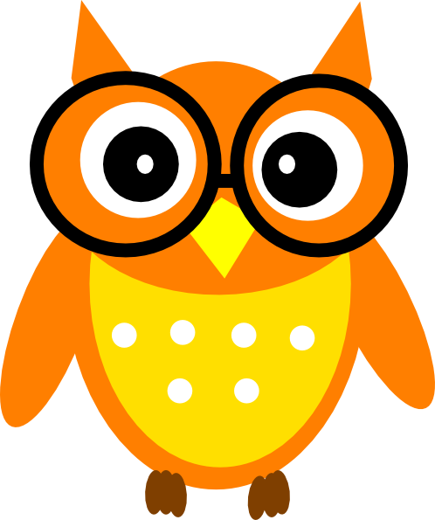

Third Grade News

October 2018

Perfect Attendance

Isaiah Melanie Frances Shannon Rachel Elijah Morgan

Matthew Edward Londyn Harrison Jonathan Mackenzie Goshen

Mackenzie Makhi Katalin Alix Will D Jazmye Khamani Kaliyah

Khonner Desmond Ryun Chase Grae Dylan Taylah Will R

Amber Austin Sydney

Email Addresses:

Samantha Altmann saltmann@tunbridgepcs.org

Mary Grant mgrant@tunbridgepcs.org

IMPORTANT DATES

10/3 Early Release Day @11:30

10/19 No School

10/22 Vision Screening

10/26 Dollar Denim Day

10/27 Tunbridge Outdoor Day

10/29 Fun Run

11/2 Purple Friday

*Snack Time!*

Please send in some snacks to share or donate $5 to our snack fund.

Thank you!